Please write in BLOCK CAPITALS throughout this form
NB. please continue on a separate sheet if necessary quoting the section to which you are referring (1, 2, 3 etc.)

Council | Branston Parish Council
Date Elected | 27/04/2021 (Co-option)
Surname | Riley
Forename(s) | Andrew David
General Declaration:
I, being a member of the above Council, give notice that I have set out my interests below
under the appropriate headings, and I have put “none” where I have no such interests.

1 | Employment  Please show every employment, office, trade, profession or vocation which a Relevant Person (see Definitions below) carries on for profit or gain. It does not include unearned income from property or investments. It would be helpful if you could also include in brackets the capacity in which you are working (e.g. employed, self-employed, partner, etc.).  Where there are no such interests, please indicate “none” in the relevant column.
 | Self | Relevant Person
 | (employed)  IPL – Telford  (International Procurement & Logistics)  Unit E  Hortonwood 31  Telford  Shropshire  TF1 7GS  (SHE Advisor)  (Health, Safety & Environmental Advisor) | (employed)  Joshua Adrian Bentley  Rockwood Academy  Naseby Road  Alum Rock  Birmingham  B8 3HG  (Business Manager)
2 | Sponsorship  You must include any payment or provision of any other financial benefit (other than from the Council itself) made or provided within the previous 12 months in respect of any expenses incurred by you in carrying out your duties as a member, or towards your election expenses. This includes any payment or financial benefit from a trade union within the meaning of the Trade Union and Labour Relations (Consolidation) Act 1992. It also includes party political organisations, someone who provides an office for you to hold a ward surgery in, etc.  Where there are no such interests, please indicate “none” in the relevant column.
 | Self | Relevant Person
 | None | None
3 | Contracts  This includes any contract which is made between a Relevant Person or a Relevant Body and the Council:  (a) under which goods or services are to be provided or works are to be executed; and  (b) which has not been fully discharged.  Where there are no such interests, please indicate “none” in the relevant column.
 | Self | Relevant Person
 | None | None
4 | Land  This section is for any beneficial interests which a Relevant Person has in Land within the Borough. You must include your home address here, if you live within the Borough/parish, even if you do not own the property. You do not need to include any Land outside the Borough.  Where there are no such interests, please indicate “none” in the relevant column.
 | Self | Relevant Person
 | 17 Mulberry Way  Branston Leas  Branston  Burton upon Trent  DE14 3FX | 17 Mulberry Way  Branston Leas  Branston  Burton upon Trent  DE14 3FX  36 Chamberlain Close  Uttoxeter  Staffordshire  ST14 8ET
5 | Licences  Please show here any licence which a Relevant Person has (alone or jointly with others) to occupy land in the Borough for a month or longer.  Where there are no such interests, please indicate “none” in the relevant column.
 | Self | Relevant Person
 | None | None
6 | Corporate Tenancies  You must include any tenancy where you know that:  (a) the landlord is the Council; and  (b) the tenant is a Relevant Body.  Where there are no such interests, please indicate “none in the relevant column.
 | Self | Relevant Person
 | None | None
7 | Securities  Please show any beneficial interest which a Relevant Person has in Securities of a body where:  (a) you know that that body has a place of business or land in the Borough; and  (b) either:  (i) the total nominal value of the Securities exceeds £25,000 or one hundredth of the total issued share capital of that body; or  (ii) if the share capital of that body is of more than one class, the total nominal value of the shares of any one class in which the relevant person has a beneficial interest exceeds one hundredth of the total issued share capital of that class.  The nominal value of shares is their face value, not their current market value e.g. the nominal value of 10,000 “£1.50 shares” is £15,000 and they would not need to be declared even if they are worth, say, £45,000. If you are in doubt about the nominal value, please contact your broker.  Where there are no such interests, please indicate “none” in the relevant column.
 | Self | Relevant Person
 | None | None
8 | Other Interests  Please indicate any other interests below.  Where there are no such interests, please indicate “none” in the relevant column.  - I am a member or hold a position of general control or management of the following organisation(s) to which I have been appointed or nominated by the Authority:
 | Self |  | Relevant Person
 | None |  | None
- I am a member or hold a position of general control or management of the following
public authority(ies) or organisations exercising functions of a public nature:

 | Self |  |  | Relevant Person
 | None |  |  | None
 | - I am a member or hold a position of general control or management of the following organisations directed to charitable purposes:
 | Self |  |  | Relevant Person
 | None |  |  | None
 | - I am a member or hold a position of general control or management of the following organisations whose principal purposes include the influence of public opinion or policy (including political party/Trade Union)
 | Self |  |  | Relevant Person
 | Unite (Member) |  |  | Unite (Member)
Statement by Member:

I confirm that I have read the Guidance Notes included with this form. I recognise that I have a legal duty to complete this form and that I must not:
- omit information that ought to be given in this notice; nor

(b) provide information that is materially false or misleading.

I acknowledge that I must give further notices within 28 days of any change:
- to update information previously given; and

(b) to declare any new interest that I acquire after the date of this notice and which I am required to declare.

Signature of Member 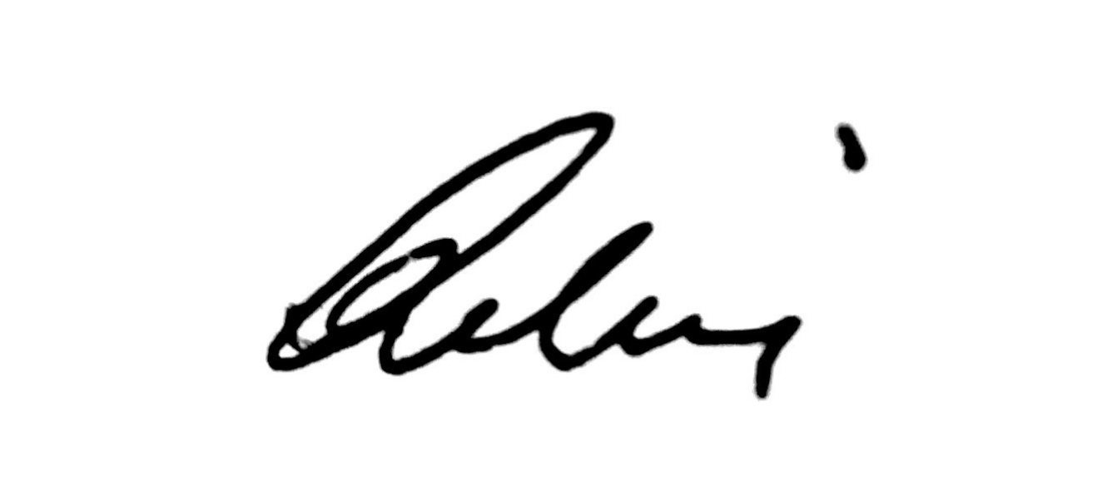 |  |  |  |  | Date 29/04/2021
Date of Receipt by Democratic Services (office use only)

“Relevant Person” means the Councillor or: - that Councillor’s spouse or civil partner; - a person with whom that Councillor is living as husband and wife; or - a person with whom that Councillor is living as if they were civil partners.
“Relevant Body” means: - a firm in which the Relevant Person is a partner; or - a body corporate of which the Relevant Person is a Director, or in the securities of which the Relevant Person has a beneficial interest.

